**Accessing the Registry**

Type regedit in Start→Search

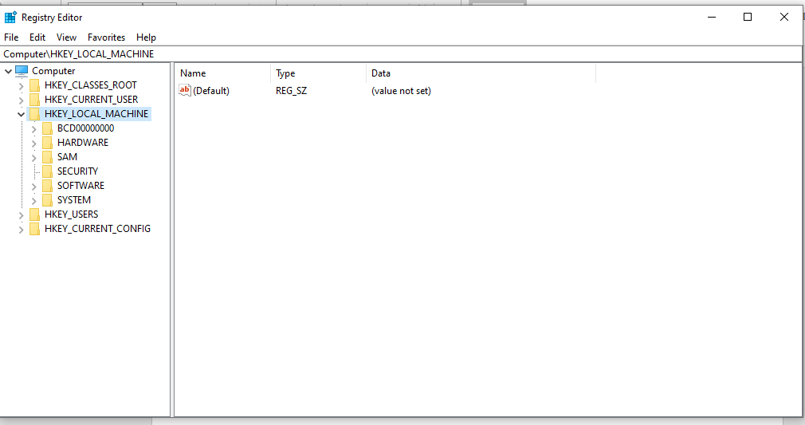

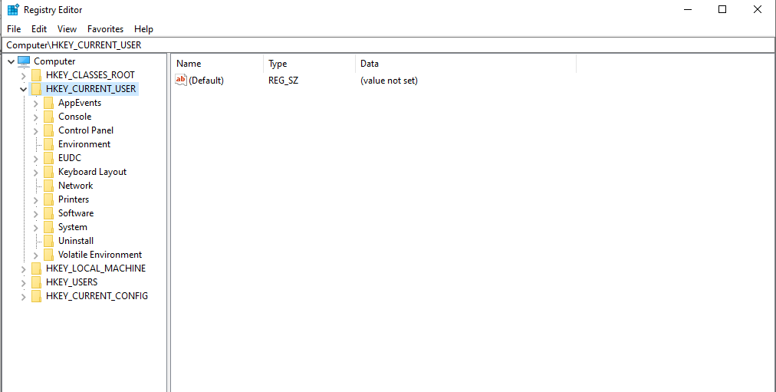

**Wireless Evidence in the Registry**

HKEY_LOCAL_MACHINE\SOFTWARE\Microsoft\WindowsNT\CurrentVersion\NetworkList\Profiles

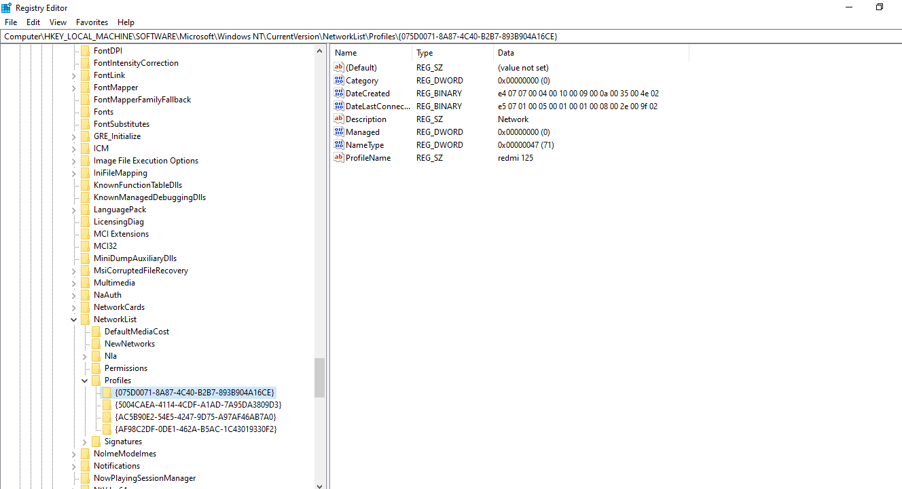

**The RecentDocs Key**

HKEY_CURRENT_USER\Software\Microsoft\Windows\CurrentVersion\Explorer\RecentDocs

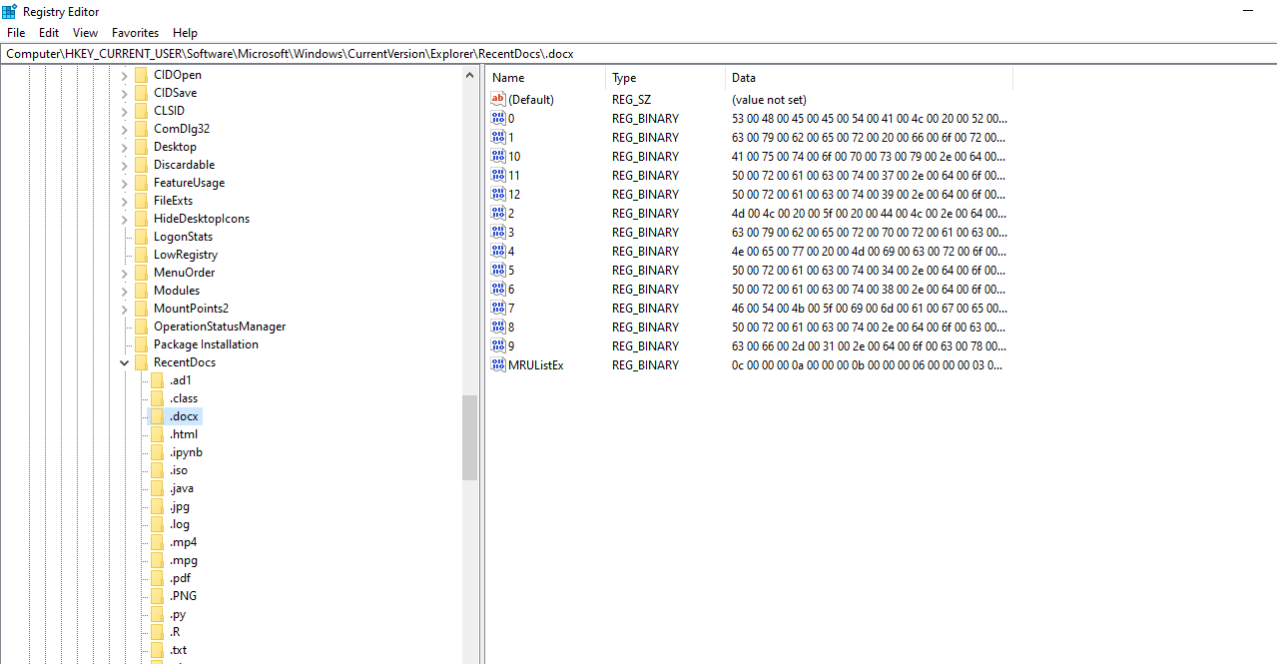

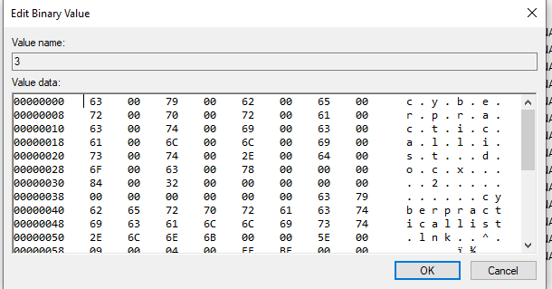

**TypedURLs Key**

HKEY_CURRENT_USER\Software\Microsoft\Internet Explorer\TypedURLs

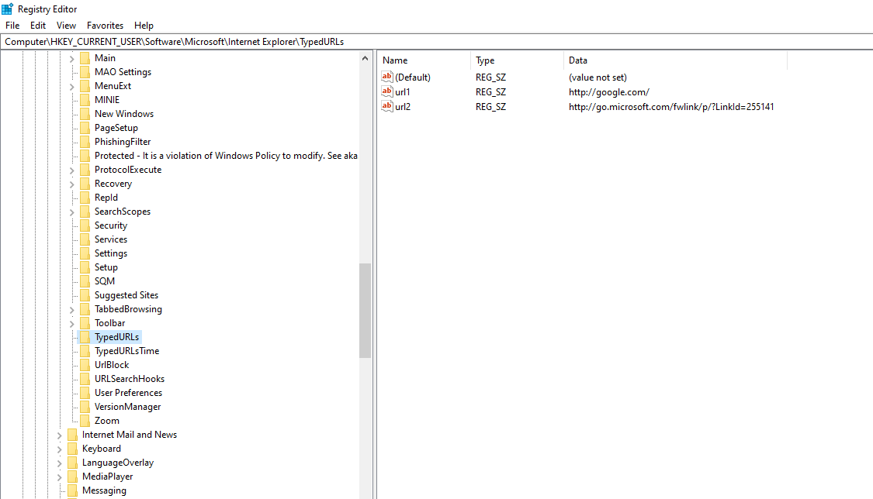

**IP Addresses**

HKEY_LOCAL_MACHINE\System\Services\CurrentControlSet\services\Tcpip\Parameters\Interfaces

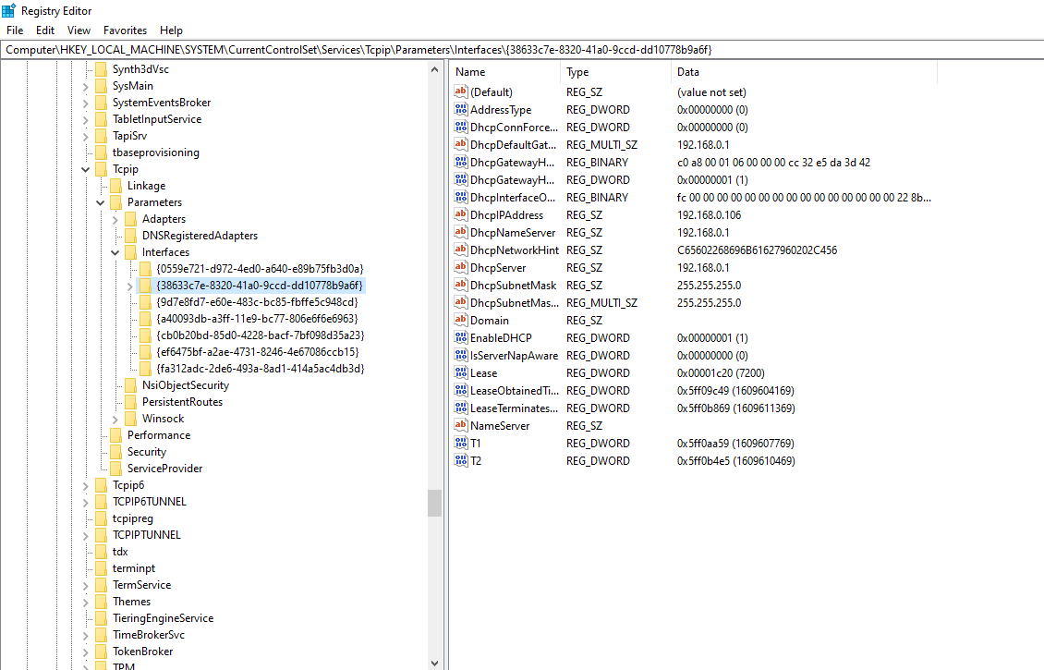

**Start Up Locations in the Registry**

HKEY_LOCAL_MACHINE\Software\Microsoft\Windows\CurrentVersion\Run

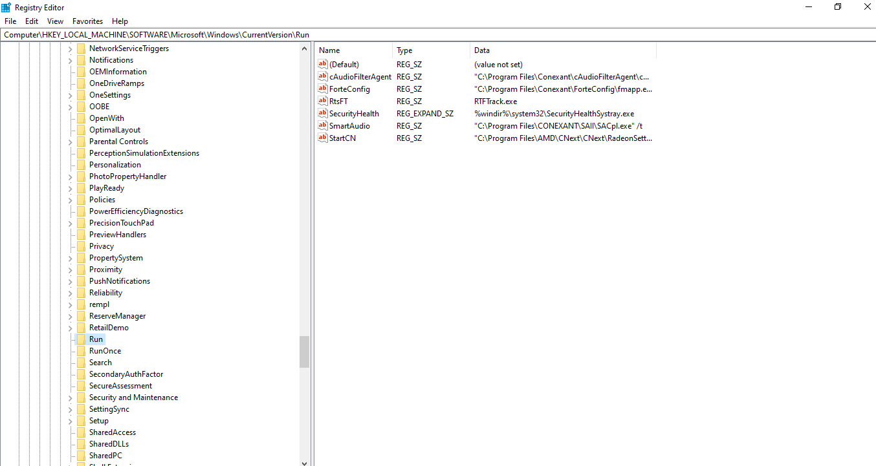

**RunOnce Startup**

HKEY_LOCAL_MACHINE\Software\Microsoft\Windows\CurrentVersion\RunOnce

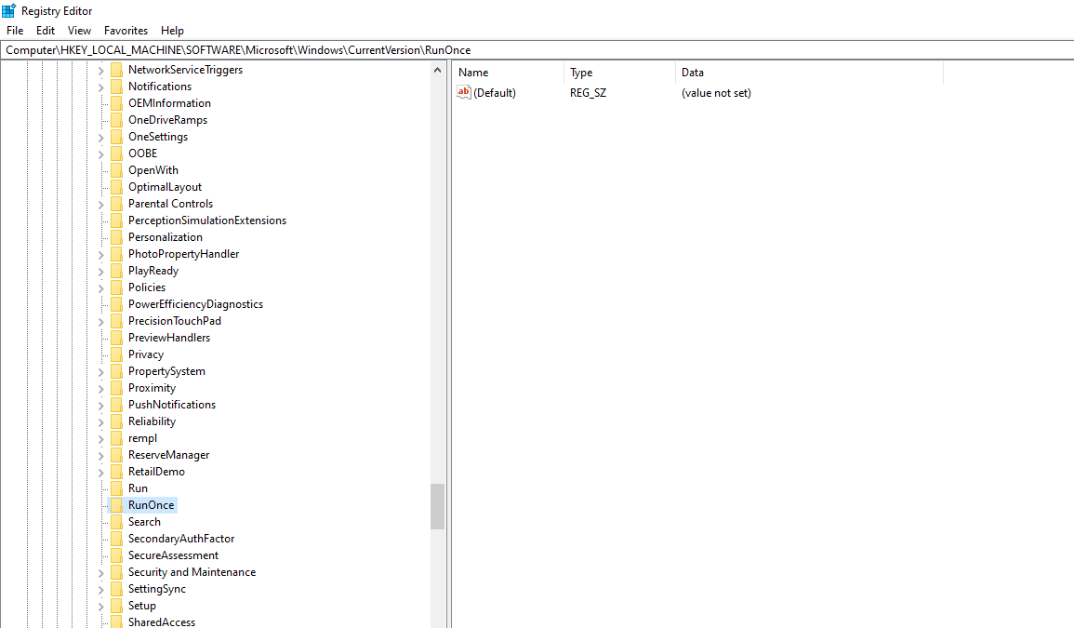

**Start Up Services**

HKEY_LOCAL_MACHINE\System\CurrentControlSet\Services

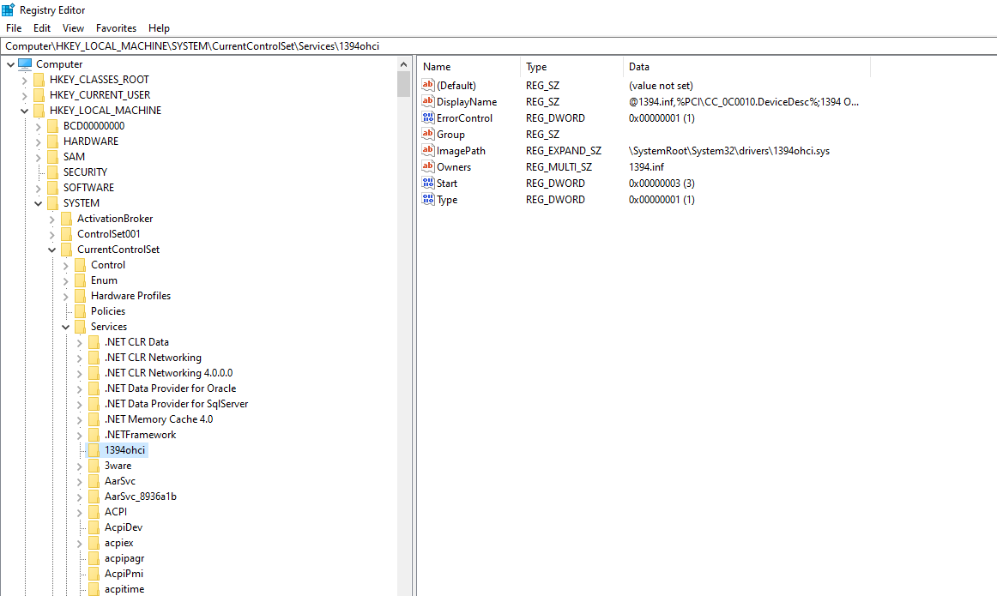

**Start Legacy Applications**

HKEY_LOCAL_MACHINE\System\CurrentControlSet\Control\WDI

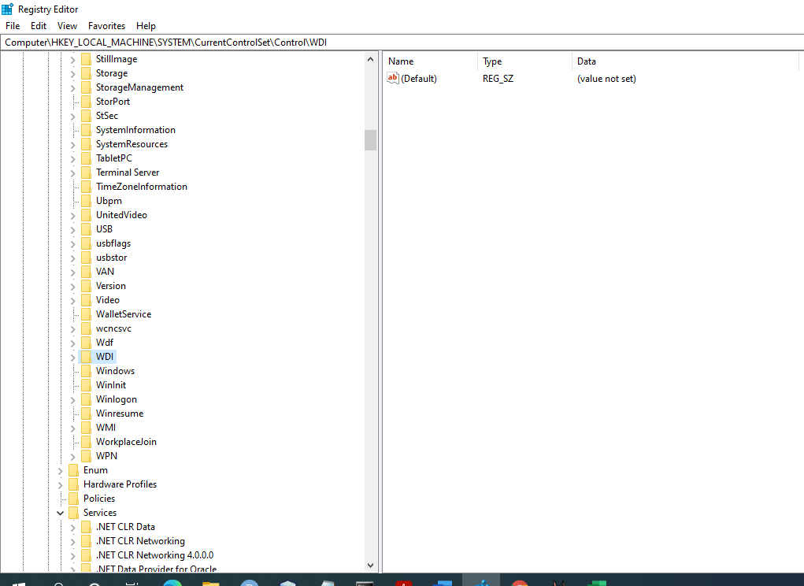

**Start When a Particular User Logs On**

HKEY_CURRENT_USER\Software\Microsoft\Windows\CurrentVersion\Run

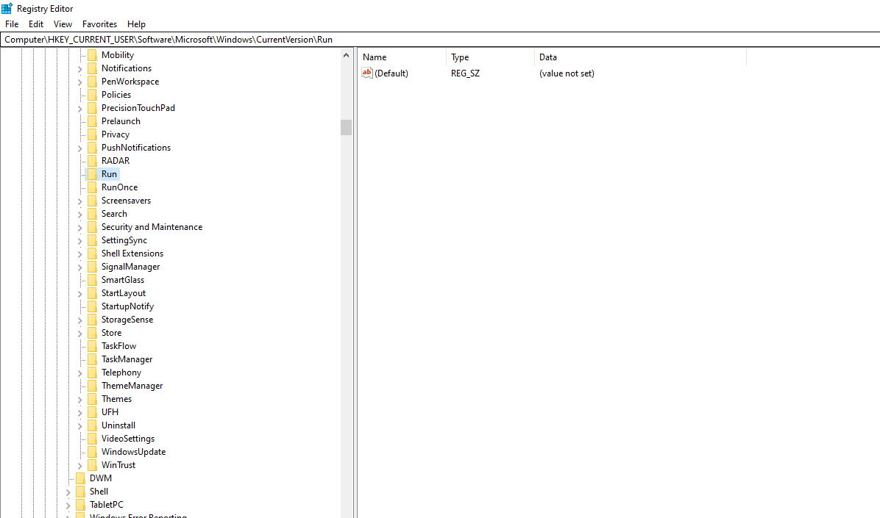

**USB Storage Devices**

HK_Local_Machine\System\ControlSet00x\Enum\USBSTOR

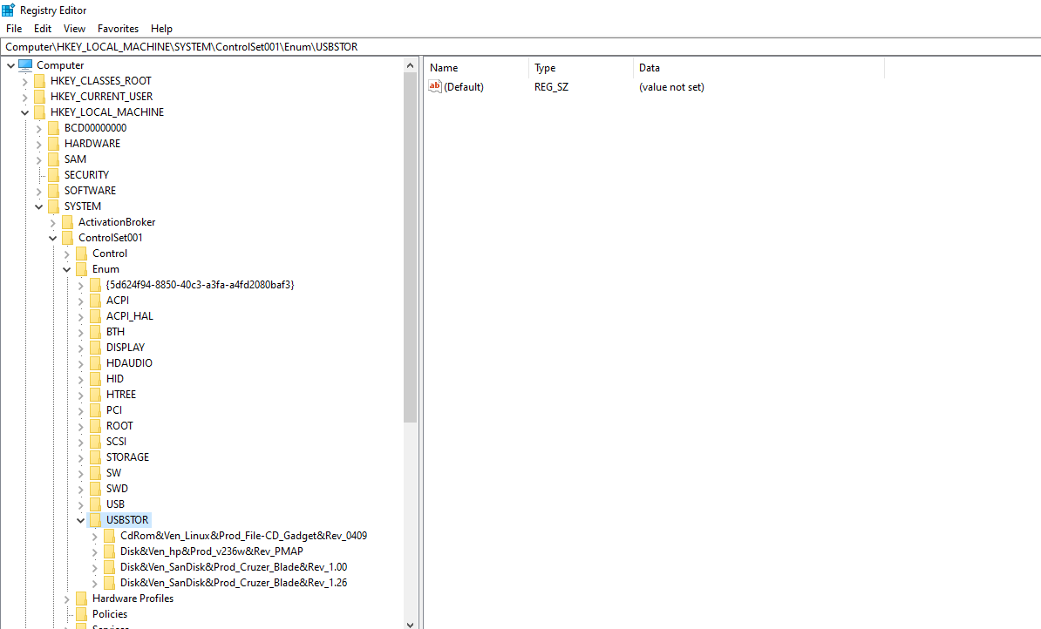

**Mounted Devices**

HKEY_LOCAL_MACHINE\System\MountedDevices

